Adult Education Series
Global Warming and Judaism
January 24, 2013
Hazzan Rob Menes

Global Warming and Judaism: How Judaism Responds to Environmental Issues

Basic Objective: To identify those aspects of Judaism which enable us to discuss, assess, and act on emerging concerns over our physical environment

- What is Global Warming and what makes it unique?
- What is the relationship between Judaism and Nature?
- What questions must a Jew wrestle with in order to identify action regarding Global Warming?

What is Global Warming and what makes it unique?

[See the Climate Change 2007 report from the Intergovernmental Panel on Climate Change]

- Global warming is the phenomenon of increasing mean surface temperature of the Earth, identified through direct temperature measurements from the mid 1800s to the present. This was not perceived to be a significant issue until the accompanying changes in atmospheric chemistry were related and indicated the influence of human activities. In particular, the measurements of increased CO2 concentrations at Mauna Loa from 1958 on indicated a possible interaction between human activities and global temperature.
- Earth surface temperature is a function of the interaction of the Sun with our atmosphere and the surface. The impact of various gases on the Earth’s ability to retain heat energy as transmitted via the Sun’s light has been known for many years (the Greenhouse effect), but identifying the intricacies of the process (reabsorption of various gases) has only recently been investigated. The gases that have the most significant impact on the earth’s energy balance are CO₂, CH₄, and N₂O (carbon dioxide, methane, and nitrous oxide).
- There is a relationship between the atmospheric gases impacting temperature and human activities. CO₂: oxidation/combustion of organic materials (burning/breakdown of wood and fossil fuels for energy production and transportation); CH₄: oxidation of animal/human wastes (livestock production); N₂O: anaerobic processes, particularly in rice production.
- Global temperature is difficult to measure.
- Impacts require mathematical/computer modeling. Data collection and Modeling imply uncertainties in the predictions.
- Results of the modeling have huge economic impacts. Constraining the release of gases as a result of human activity implies an absolute constraint on economic development.
- As a global issue, solutions are global and require cooperation.
- Since activities are not equally distributed, constraints will not be equal.

The scientific evidence for global warming and the impact of human activities on global warming is extensive and compelling. There is no evidence disproving the trend or the basic model. However, there is room for disagreement in the following areas:

- the projected extent of warming
- the impacts of warming and the regional variation in the impacts
- the contribution of human activities to warming
- the need for action
- the areas or activities which should be altered
- the constraints on development for developing countries

There is an overriding philosophical issue: if global warming is a natural phenomenon, should we attempt to reverse it? If it is primarily due to human activities, do we have a responsibility to reverse it?
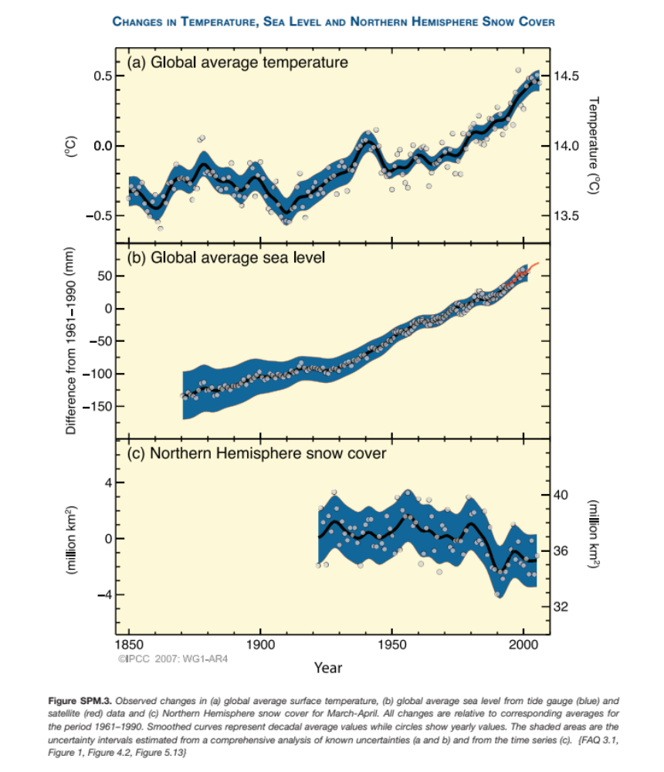

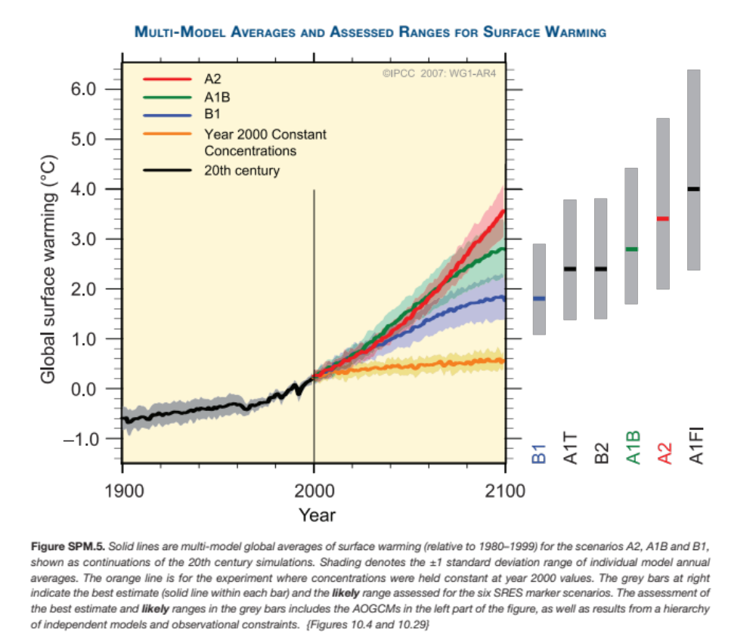

What is the relationship between Judaism and Nature?

Robert Gordis’s article, “Ecology and the Judaic Tradition”, in Contemporary Jewish Ethics and Morality (Dorff and Newman, eds) describes the basis for an environmental ethic in Judaism based on the sacred texts. In particular, there are 4 particularly salient messages from the Tanakh and Talmud that can inform our approach to global warming:

- The dominion of man over the Earth, from Gen. 1:28: God blessed them and said to them: ‘Be fruitful and multiply, and replenish the earth, and subdue it; and have dominion over the fish of the sea, and over the fowl of the air, and over every living thing that moves on the earth.” Although this has been interpreted to imply that man can do whatever he chooses with the earth, Gordis points out that man is not even granted full use of the animals at this point in the text. Rather, this text should be interpreted as an indication of the intention of man to be fertile and manipulate the earth to that end.
- The role of man as caretaker for the earth: Gen. 2:15: ‘He placed him the Garden of Eden to till it and to guard it. ‘Man has an obligation to care for the earth. Furthermore, it is made clear in passages that man does not own the earth, the earth is God’s and all therein. Thus, we have the concept of the sh’mitta and jubilee years.
- The concern for reducing the pain of living creatures and recognizing the reverence for life: tza’ar ba’alei chayim. A number of laws identified in Torah to ease the burden of animals – not to yoke together the ox and the donkey, not to slaughter a cow and its offspring on the same day, not to muzzle and ox in the field, etc.
- The Talmudic tradition of bal taschit – “do not destroy.” This is taken from Deut 20:19-20 regarding the preservation of the trees during a siege. This is the opposite of defoliation, or complete destruction of an area. Gordis cites the prohibition of pollution by various activities in Bava Batra 2:8-9, and Bava Kama 82b.

In Genesis, God intercedes in natural processes, and throughout the ages, the rabbis have commented on the role of God in the ‘miraculous.’ Maimonides maintained that God set in motion the forces of nature and, even in the time of the messiah, these will not change. Nachmanides sees it differently, expecting God to radically alter nature as we know it. In post-biblical timesit is largely accepted that people are the instruments of God’s miracles, that the interactions of nature may not be understood, but they are fixed and unlikely to be cataclysmically altered by God. Thus, if the Earth is to be protected it is up to us to protect it.

It also seems that man does have the ‘right’ to impact the environment – to plant, irrigate, harvest. The limits of the impact can be guided by the 4 concepts above: increase fertility, caretake for the future, revere all products of creation, and not destroy.

What questions must a Jew wrestle with in order to identify action regarding Global Warming?
Given the information we have about Global Warming, and given Judaism in law and tradition, how does the Jew decide what to do about Global Warming, or, any emerging environmental issue?

First, the individual must ascertain that the problem is real. Global Warming is real. Is it a problem?

a. Global warming is a fact
b. IF GW is perceived to be a problem, then
does Judaism call on us to intercede, change nature, if it is NATURAL?
does Judaism require us to intercede if it is man-induced?
does Judaism require us to intercede if it does not impact us directly?
does Judaism require us to intercede if doing so will hurt Israel?

Discussion begins here.

