
Coffee with the Cantor
2018
Hazzan Rob Menes
Wednesdays, 11:00-12:30
http://www.hazzanmenes.com

Perceptions of Modern Judaism
Judaism and Politics – What’s the Connection?

http://news.gallup.com/poll/180422/three-american-jews-identify-republicans.aspx?version=print
JANUARY 6, 2015

About Three in 10 American Jews Identify as Republicans
by Frank Newport

Story Highlights
- 29% of American Jews are Republican, up from 22% in 2008
- 61% of Jews are Democrats, down from 71% seven years ago
- Highly religious and male Jews are most likely to be Republican
WASHINGTON, D.C. -- In 2014, 29% of Jewish Americans identified as Republicans or leaned Republican, little changed in recent years, but higher than in 2008. Meanwhile, 61% of American Jews identified as Democrats or leaned Democratic, down from 71% in the strongly Democratic year of 2008.
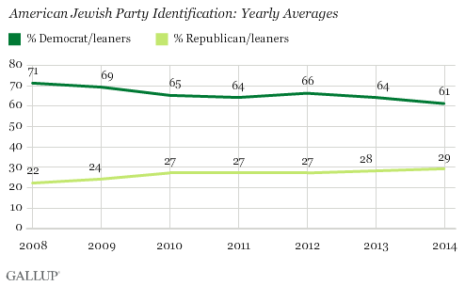
The diminished Democratic skew among American Jews in recent years is slightly more pronounced than the same trend among all Americans. The percentage of the general population that identifies with or leans Democratic has fallen by about seven percentage points since 2008, compared with the 10-point drop among Jews. The percentage that identifies with or leans Republican among the general population is up three points, compared with the increase of seven points among Jews.
These results are based on 2014 Gallup Daily tracking interviews with 4,116 Americans who identified their religion as Jewish.
Jews in the U.S. are proportionately well-represented in Congress, with 28 members of the 535 House and Senate members in the new Congress identifying their religion as Jewish, meaning that about 5% of all House members and Senators are Jewish, compared with the 2% of the adult population. Of these Jewish members of Congress, all are Democrats or independent, with the one exception being newly elected Republican Rep. Lee Zeldin of New York.
Jewish Partisanship Varies by Gender, Religiosity and Education
As is the case with other Americans, Jewish Americans' political leanings vary significantly by religiosity, gender and education. Jewish men are more Republican than Jewish women, highly religious Jews are more Republican than less religious Jews, and Jews with lower levels of education are more likely to be Republicans than those with more formal education.
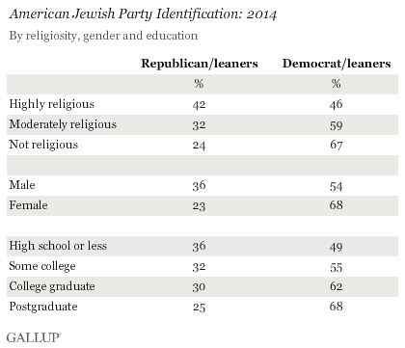
All of these patterns among the Jewish population reflect those evident in the overall U.S. population. The Democratic skew among women is well-established, highly religious Americans are more Republican than those who are less religious, and Americans with postgraduate educations are more likely to be Democratic than those with less education.
Two of the Jewish segments with the highest Republican representation constitute a relatively small proportion of the overall Jewish population, which helps explain the two-to-one overall Democratic-to-Republican Jewish ratio. Jews as a group are not very religious, with only 19% classified as highly religious, less than half of the percentage of all Americans who are highly religious (41%). Jews tend to have higher levels of education on average, leaving only 34% who do not have a college degree, compared with 69% of the general population
There are few systematic differences in party identification in the Jewish population across age, income or region of country.
Bottom Line
The general Democratic orientation of American Jews is a well-established political fact, although this Democratic slant has decreased marginally in recent years, as it has among the general U.S. population. Given the small sample sizes of the Jewish population in traditional surveys, it is difficult to determine precisely those issues on which Jewish Democrats nationally may differ from Jewish Republicans, although most news accounts suggest that U.S. relations with Israel is certainly one of them. The Jewish Republican minority in the U.S. is politically active, including the efforts of the Republican Jewish Coalition, which will hold its national leadership reception in Washington, D.C., on Jan. 6 with prominent Republican members of Congress expected to be in attendance. The direct influence of Jewish Republicans in Congress may be lessened with the departure of former House Minority Leader Eric Cantor, who was defeated in his Virginia Republican primary election last year.
Survey Methods
Results for this Gallup poll are based on telephone interviews conducted Jan. 2-Dec. 30, 2014, on the Gallup U.S. Daily tracking survey, with a random sample of 4,116 adults who identify their religion as Jewish, aged 18 and older, living in all 50 U.S. states and the District of Columbia. For results based on the total sample of Jewish adults, the margin of sampling error is ±2 percentage points at the 95% confidence level. All reported margins of sampling error include computed design effects for weighting.
Each sample of national adults includes a minimum quota of 50% cellphone respondents and 50% landline respondents, with additional minimum quotas by time zone within region. Landline and cellular telephone numbers are selected using random-digit-dial methods.
Learn more about how Gallup Daily tracking works.

https://fivethirtyeight.com/features/how-the-gop-became-a-pro-israel-party/

DEC. 8, 2017 AT 10:57 AM

How The GOP Became A ‘Pro-Israel’ Party
By Rebecca Shimoni Stoil
Filed under Foreign Policy

President Trump, seen here with Israeli Prime Minister Benjamin Netanyahu, recently agreed to move the U.S. Embassy to Jerusalem.
BRENDAN SMIALOWSKI / AFP / GETTY IMAGES
A host of Israeli leaders and pro-Israel voters had long been advocating for the decision that President Trump announced on Wednesday, which recognized Jerusalem as the capital of Israel and began the process of relocating the U.S. Embassy from Tel Aviv. The fact that the controversial decision was carried out by a Republican president is indicative of the dramatic change in the GOP’s position on Israel since Israel was founded.
The Republican party has moved from not supporting Israel enough, in the eyes of many Jewish Americans, to backing policies that now go further than the positions espoused by many Jewish voters — but are in keeping with the views of evangelical voters. As bipartisan support for Israel erodes, the controversial move risks further accelerating a growing party split.
Jewish Americans have for decades voted overwhelmingly for the party of Franklin D. Roosevelt, who defeated Hitler and was beloved for his New Deal policies, and Democrats were the party that championed Israel when it was first established in 1948. In contrast, Israel and the Republican Party had a tumultuous relationship early on. In the 1950s, following Democratic President Harry Truman’s recognition of the state of Israel, support for the country within the Republican Party and the conservative movement was highly limited. Since the vast majority of Jews were Democrats, there was little push from within the GOP to support the newborn nation.
The GOP’s domestic and foreign policy orientation in that era didn’t strengthen the case for the party supporting Israel either: The Middle Eastern country’s socialist bent scared away the anti-communists in the Republican Party, and the GOP’s foreign policy pragmatists were concerned that support for Israel would undermine America’s ties with the increasingly important oil-producing nations in the Middle East, many of which had fought against Israel when it declared independence.
Typical of Republican sentiment at the time were the critiques of Israel published in The National Review. Political philosopher Leo Strauss went so far as to write a letter in 1956 to complain. The journal’s editor, Willmoore Kendall, acknowledged there was an “anti-Israel bias among my colleagues, and in Right-wing circles in general.”
Although Kendall emphasized that he did not believe that anti-Semitism was behind that bias, successive Republican presidents were eyed warily by many pro-Israel Jews well into the George H.W. Bush administration. Richard Nixon, though he supported Israel in the 1973 Arab-Israeli War, was believed to be a raging anti-Semite (a belief that was vindicated when tapes of his conversations were released decades later), and even Ronald Reagan’s support for Israel was questioned when he penalized the Jewish state for its bombing of Iraq’s nuclear reactors.
By the end of the 1990s, though, attitudes began to shift, due largely to world events, changes in a major GOP constituency and changes in the Jewish community. Israeli politics also played a role.
The most pronounced turning point in GOP voters’ support for Israel came after 9/11, as increased U.S. military involvement in the Middle East resulted in more pro-Israel policies percolating into the Republican agenda. Israel was struggling with its own upswing in terrorist attacks, so many influential conservatives saw new relevance in Samuel Huntington’s model for a clash of civilizations in which Israel and the United States were aligned as members of “the West,” in opposition to other cultures — in this case, Islam.
At the same time, the Jewish community was increasingly made up of baby boomers who had rejected their parents’ affinity for the Democratic party and found themselves at home in Republican administrations seeking to project American power and values. They also took on key roles in campaigns, both as donors and advisers, which allowed them to bring more attention to their top issues.
Starting as early as 2004, casino mogul Sheldon Adelson, for example, began to throw his financial weight behind Republican candidates, whom he said better represented his values — and especially his support for Israel. Writing in The Wall Street Journal in 2012, Adelson explained that he had left the Democratic Party because it had changed, becoming home to “a visceral anti-Israel movement among rank-and-file Democrats.”
It can be argued whether Adelson’s assessment was fair, but public opinion polls over the last decade have suggested that Democrats’ support for Israelhas cooled even as support among GOP voters increased.
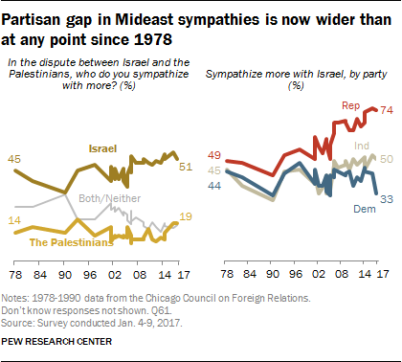
In some ways, Israeli politics themselves have contributed to the Republican Party’s shift in views. Since the mid-1990s, the Israeli right wing has been dominated by Benjamin Netanyahu, who served as prime minister for part of that decade and now holds the office again. Netanyahu broke away from the traditionally statist Israeli right to support economic policies that lined up with those of U.S. economic neoliberals. He shares a major supporter — Adelson — with many top U.S. Republicans, and he has cultivated personal relationships with U.S. Republican leaders.
When Republicans now look to Israel, they see in Netanyahu a leader cut from a similar ideological cloth to many of their own representatives — not just in terms of foreign policy beliefs but also in economic positions, one who shares a Republican skepticism of the welfare state and embraces free markets. A 2015 poll found that Republicans ranked Netanyahu alongside Ronald Reagan as the “national or world leader you admire most.” Netanyahu’s headline-grabbing tussles with then-president Barack Obama, which alienated many Jewish Democrats, only served to raise his profile among Republicans.
But perhaps most importantly, since the 1990s, evangelical Christians have come to represent one of the strongest and most hawkish pro-Israel demographics within the Republican party. Until the 1970s, evangelicalstended to avoid direct involvement in political activism. When Jerry Falwell’s Moral Majority emerged at the end of that decade, fusing religion and politics, Israel wasn’t the top issue. But Falwell did emphasize that evangelicals — a group that at times had had mixed attitudes toward Jews and Israel — should understand their theology as strongly backing Israel. (Many pro-Israel evangelicals believe that Israel is essential to the second coming of Jesus or that they are following a literal interpretation of a Biblical injunction that God will bless those who bless Israel and curse those who curse Israel.) In the early ’80s, support for Israel dovetailed with strong anti-communism, as evangelicals slammed the Soviet Union for maintaining harsh policies restricting Jewish and Zionist activities.
Today, Israel is a voting priority for many evangelicals. A 2015 poll noted that 64 percent of evangelical Christian Republicans say that a candidate’s stance on Israel matters “a lot,” compared with 33 percent of non-evangelical Republicans and 26 percent of all Americans.
And evangelical Christian voters, unlike Jews, represent a significant percentage of Republican voters. Some 26 percent of the electorate identifiedin the 2016 elections as born-again or evangelical Christian, and 81 percent of them voted for Trump over Hillary Clinton. Capturing evangelical support is essential for Republican candidates; as of 2014, evangelical and born-again voters represented the plurality (45 percent) of voters who are Republican or who lean Republican.
Propelled by evangelicals, the GOP has in many cases become more hawkish than most U.S. Jews. While the Republican Party has notably turned away from traditional U.S. support for a two-state solution, which would establish a Palestinian nation alongside Israel (only 23 percent of evangelicals polled in 2017 agreed that Israel should agree to the creation of a Palestinian state), the majority of U.S. Jews believe that Israel and an independent Palestine can coexist peacefully. Although members of the Trump administration — most notably, perhaps, Mideast negotiator and Trump son-in-law Jared Kushner — support Israeli construction in the disputed West Bank, only 17 percent of U.S. Jews believe that Jewish settlements in the area help Israel’s security. An election-night poll of Jewish voters in 2016 by the dovish J Street suggested that Israel isn’t even really the primary voting issue for many Jews: Only 9 percent listed it as one of their top two voting priorities.
In fact, it is the pro-Israel evangelical community — and particularly Pastor John Hagee’s Christians United for Israel — that has mobilized alongside hawkish pro-Israel Jews to push for a change of U.S. policy on Jerusalem. Hagee, whose organization boasts over three million members, has been pushing Trump to move the embassy since the 2016 campaign season, to prove the president’s commitment to evangelical values.
The evangelical community is unusual in their support for moving the embassy to Jerusalem. A November poll indicated that 63 percent of Americans oppose the move, but 53 percent of evangelical voters support it.
Whatever GOP constituency pressed for the move the most, what matters in the end is that they succeeded. Though Democratic and Republican presidential candidates alike have long promised to recognize Jerusalem as Israel’s capital and move the U.S. Embassy there, none who won the office ever did so — until Trump.
But the president is not widely embraced by Jews as a whole (while some 50 percent of Orthodox Jews voted for Trump, the two larger streams of U.S. Judaism — Reform and Conservative — opposed Trump), so it remains to be seen whether his recognition of Jerusalem increases Jewish affinity for the Republican Party. That outcome will surely be influenced by what happens next.
Rebecca Shimoni Stoil is a lecturer in U.S. political history and a reporter formerly with The Jerusalem Post and Times of Israel. @rebeccastoil

http://www.pewforum.org/2013/10/01/chapter-6-social-and-political-views/

OCTOBER 1, 2013
Chapter 6: Social and Political Views
Jews are among the most strongly liberal, Democratic groups in U.S. politics. There are more than twice as many self-identified Jewish liberals as conservatives, while among the general public, this balance is nearly reversed. In addition, about seven-in-ten Jews identify with or lean toward the Democratic Party. Jews are more supportive of President Barack Obama than are most other religious groups. And about eight-in-ten Jews say homosexuality should be accepted by society.
Interestingly, one Jewish subgroup does not fit this liberal, Democratic profile: Orthodox Jews. Roughly half of Orthodox Jews describe themselves as political conservatives, and 57% identify with or lean toward the Republican Party. And in their attitudes about homosexuality, Orthodox Jews more closely resemble evangelical Protestants than other Jews, with nearly six-in-ten saying homosexuality should be discouraged by society.
The survey also asked Jews about their perceptions and experiences of discrimination. Roughly one-in-seven say they have been called an offensive name or been snubbed in a social setting during the past year because they are Jewish. About four-in-ten say there is a lot of discrimination against Jews in the U.S. today, but this is much lower than the percentage of Jews who perceive a lot of discrimination in America against some other minorities, such as gays and lesbians, Muslims, blacks and Hispanics.

Partisanship and Ideology
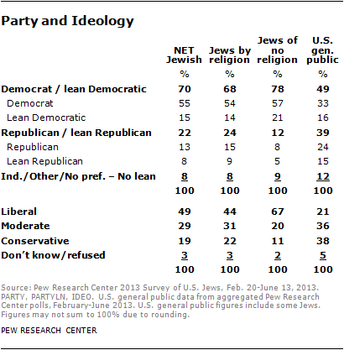U.S. Jews are a largely Democratic, politically liberal group. Overall, seven-in-ten Jews (including 68% of Jews by religion and 78% of Jews of no religion) identify with or lean toward the Democratic Party, while just 22% identify with or lean toward the Republican Party. And roughly half of U.S. Jews describe themselves as political liberals (49%), including 44% of Jews by religion and two-thirds of Jews of no religion (67%). By comparison, the general public is much more evenly divided between the two parties (49% identify with or lean toward the Democratic Party, while 39% identify with or lean toward the GOP) and is much less politically liberal.
In Pew Research surveys conducted since 2000, the partisanship of Jews by religion has shown some variability, but they have always identified with the Democratic Party over the GOP by large margins. Roughly two-thirds of Jews by religion have identified as Democrats or Democratic-leaners over the past decade, and there has never been a year in which support for the Democratic Party has dipped below 62%.
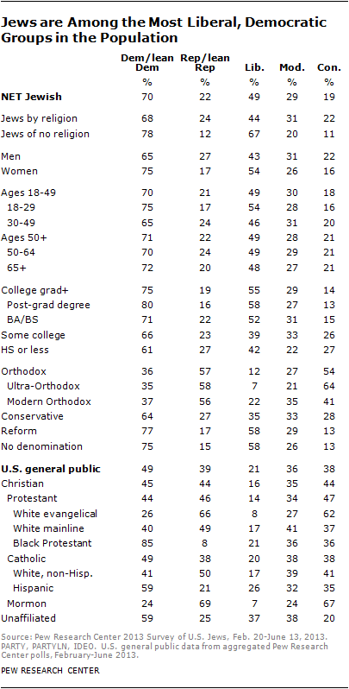
Jews by religion are more than twice as likely as members of most other religious traditions to describe themselves as politically liberal. And black Protestants are the only religious group with a larger share than Jews by religion that identifies with or leans toward the Democratic Party. For their part, Jews of no religion are even more politically liberal and Democratic-leaning than is the overall religiously unaffiliated population, which itself is among the most strongly liberal and Democratic groups in the population.
But while Jews overall are a strongly liberal, Democratic group, there are pockets of conservatism and Republicanism within the Jewish population. Orthodox Jews identify with or lean toward the Republican Party over the Democratic Party by a 57% to 36% margin. And 54% of Orthodox Jews, including 64% of Ultra-Orthodox Jews, consider themselves politically conservative. On these measures (partisanship and ideology), the only other U.S. religious groups that are as conservative and Republican as Orthodox Jews are white evangelical Protestants and Mormons.
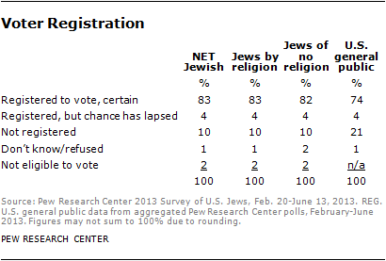Upwards of eight-in-ten Jews (83%) say that they are absolutely certain they are registered to vote at their current address. This exceeds the share of the general public that says they are registered to vote.

Views of Obama
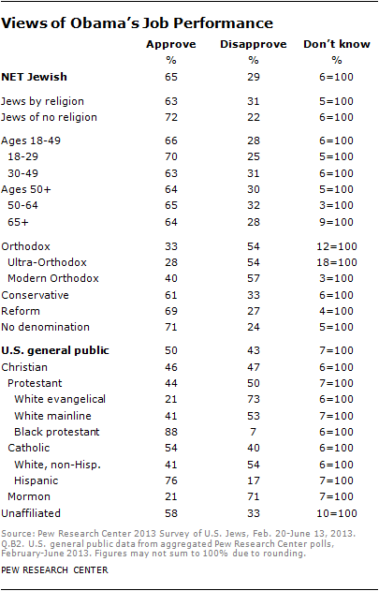
The strong Democratic leanings of Jews carry over to their views of Obama. Exit polls indicate that two-thirds of Jews by religion (69%) voted for Obama over his Republican challenger, Mitt Romney, in the 2012 presidential election. And at the time of the survey, roughly two-thirds of Jews (65%) say they approve of the way Obama is handling his job as president. By comparison, in recent Pew Research surveys, half of the general population has expressed approval of Obama’s job performance. Only black Protestants (88%) and Hispanic Catholics (76%) approve of Obama’s performance at higher rates than Jews.
For the most part, Obama receives high approval ratings across a variety of Jewish subgroups. For example, both Jewish men and women approve of Obama’s job performance at high rates (64% and 66%, respectively), as do Jews under age 50 (66%) and those 50 and older (64%). However, one group stands out for its disapproval of Obama’s performance: Orthodox Jews, among whom 54% express dissatisfaction with Obama’s handling of his job.
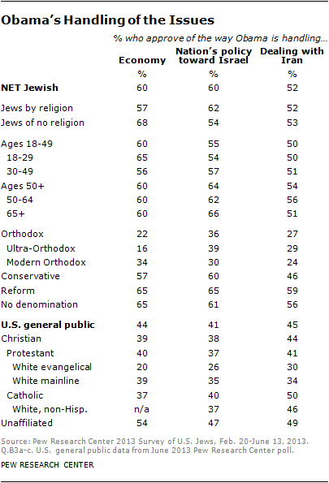
Jews’ above-average support for Obama is also seen in evaluations of his handling of specific issues, though he gets somewhat lower marks for his handling of specific issues than he does for his overall job performance. Six-in-ten Jews say they approve of the way Obama is handling the economy (60% compared with 44% among the population overall). Six-in-ten Jews also approve of Obama’s handling of the nation’s policy toward Israel (compared with 41% among the public as a whole), and 52% of Jews approve of the way Obama is dealing with Iran (compared with 45% of the public overall).
Obama receives higher marks from Jews by religion than from most other religious groups for his handling of the nation’s policy toward Israel. The strongest critics of Obama’s approach toward Israel are white evangelical Protestants, among whom just 26% approve of his performance in this area.
Orthodox Jews are more critical of Obama’s handling of these issues than are other Jews. Roughly one-third of Orthodox Jews approve of the way Obama is handling the nation’s policy toward Israel (36%), 27% approve of the way he is dealing with Iran, and just 22% give Obama positive marks for his handling of the economy.

Issues – Homosexuality and Size of Government
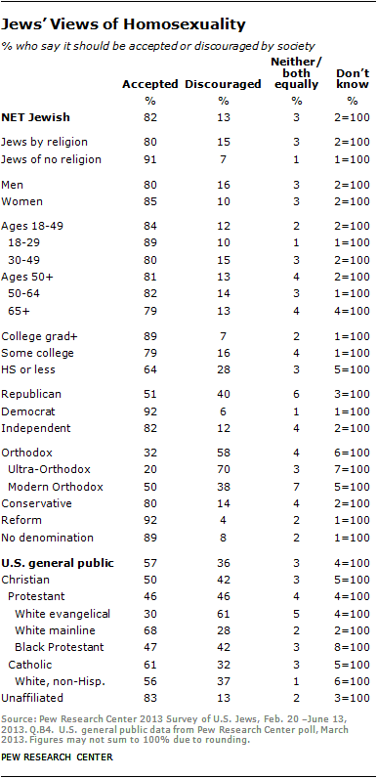
Jews are strong supporters of gay rights. For example, Pew Research surveys conducted in 2012-2013 find that 78% of Jews by religion favor allowing gays and lesbians to marry legally. By comparison, support for same-sex marriage among the general public stands at 50% in recent polling.
More generally, the current survey of U.S. Jews finds that about eight-in-ten (82%) say homosexuality should be accepted by society, while just 13% say it should be discouraged by society. Eight-in-ten Jews by religion and nine-in-ten Jews of no religion say homosexuality should be accepted by society. Compared with Jews, the general public is far less accepting of homosexuality (57%).
Jewish Republicans are less accepting of homosexuality than Jewish Democrats and independents. But Jewish Republicans are more accepting of homosexuality compared with Republicans in the general population (51% vs. 38%).
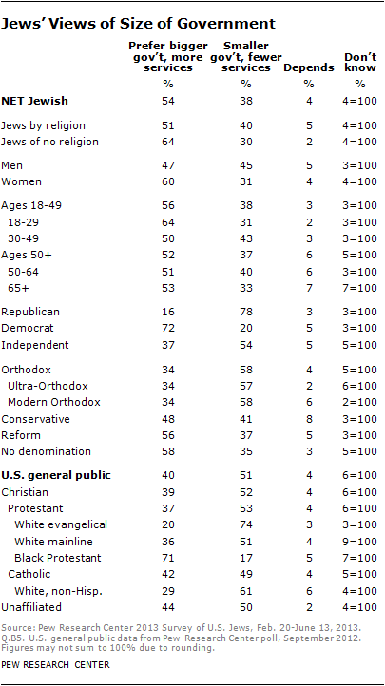
Orthodox Jews – especially the Ultra-Orthodox – are far less accepting of homosexuality than are other Jews. Seven-in-ten Ultra-Orthodox Jews say homosexuality should be discouraged by society, a level of disapproval similar to that expressed by white evangelical Protestants, among whom 61% say homosexuality should be discouraged by society. Modern Orthodox Jews are more accepting of homosexuality than Ultra-Orthodox Jews, but they still express less acceptance of homosexuality than do Jews overall.
If given just two choices, about half of the American Jewish population (54%) prefers a bigger government that offers more services, while 38% say they would prefer a smaller government providing fewer services. Among the general population, this balance of opinion is reversed, with 51% expressing support for a smaller government with fewer services and 40% desiring a bigger government with more services.
More Jewish women (60%) than men (47%) say they want a bigger government. Orthodox Jews are the only Jewish denominational group that prefers a smaller government (58%) to a larger government (34%).

Satisfaction With Country, Communities
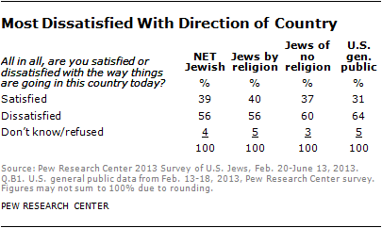
Most Jews are dissatisfied with the way things are going in the country today; 56% say they are dissatisfied, compared with 39% who are satisfied. Among the general public, 64% express dissatisfaction with the way things are going in the country, while 31% say they are satisfied.
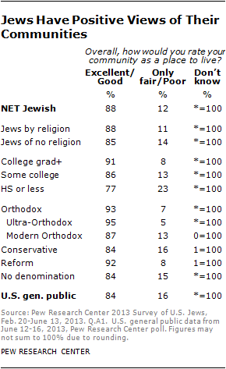
American Jews are about as likely as the U.S. population overall to rate their community as an excellent or a good place to live (88% and 84%, respectively), but Jews are considerably more likely to say their community is an excellent place to live (50% vs. 41%).
About nine-in-ten Jewish college graduates rate their community as either an excellent or good place to live (91%), as do 86% of those with some college education and a slightly smaller majority of those with a high school education or less (77%). Community satisfaction does not vary significantly across gender, age or partisanship.
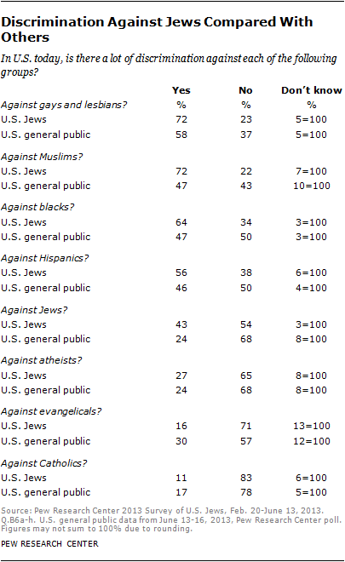

Discrimination Against Jews
More Jews say several non-Jewish groups face a lot of discrimination in American society than say this about Jews; 72% of Jews say gays and lesbians face a lot of discrimination, 72% say this about Muslims, 64% say blacks face a lot of discrimination, and 56% say the same about Hispanics. By contrast, most American Jews (54%) do not think there is a lot of discrimination against Jews in the U.S. today. A substantial minority, however, says Jews do face a lot of discrimination (43%). And Jews are more likely than the population as a whole to say that Jews face a lot of discrimination in the U.S. today (43% vs. 24% among the general public).
Compared with ratings about other groups, fewer Jews say Catholics (11%), evangelicals (16%) and atheists (27%) face a lot of discrimination in American society today.
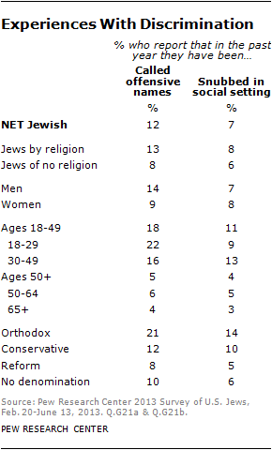
About one-in-ten American Jews say that in the past year they have been called offensive names (12%) or been snubbed in a social setting or left out of social activities (7%) because they are Jewish. Overall, 15% of Jews say they have experienced one or another of these things in the past year.
Younger Jews are more likely than others to say they have been called offensive names because they are Jewish. Among Jews under age 30, 22% say they have been called offensive names because they are Jewish, as have 16% of Jews in their 30s and 40s. By comparison, 6% of those ages 50-64 and 4% of those 65 or older say this has happened to them in the past year.

http://www.jewishpress.com/indepth/opinions/politics-and-our-perception-of-anti-semitism/2017/03/03/

Politics And Our Perception Of Anti-Semitism
By
Ben Cohen
-
5 Adar 5777 – March 3, 2017
Ben Cohen
The late Robert Wistrich elegantly summarized the character of anti-Semitism at the turn of this century.
“The old-new anti-Semitism can itself be as inventive as it is repetitive,” Wistrich wrote. “It often appears to imply that Jews are never victims but always victimizers, which may sound original to some but is clearly false. It generally avoids positions that smack of deliberate political or economic exclusion of Jews qua Jews from the national community or that echo the discourse of a discredited biological racism.
“On the other hand, depicting Zionism and the Jewish lobby as a world power is not considered racist or defamatory. There is no law against suggesting that Zionists deliberately provoke wars and revolutions, even though this is a classic anti-Semitic fabrication that has been widely propagated by Nazis, Communists and Islamists.”
In other words, anti-Semitism adjusts itself to the sensibilities of the surrounding society. It develops themes that invariably portray Jews as a collectivity in the worst possible moral light. And it is politically and theologically promiscuous, penetrating the salons of the nationalist right and the progressive left, creeping into Presbyterian churches and leading the thundering discourse of political Islam.
We can boil all that down even more simply, into two maxims. First, anti-Semitism isn’t the exclusive property of any one political faction or religious formation. Second, because anti-Semitism is something of a shape-shifter that frequently denies that it is what it is, we have trouble identifying it even when we’ve encountered it a thousand times before.
With that in mind, on then to the widely discussed recent “surge” of anti-Semitism in the U.S., manifested in small-scale but ugly incidents, among them at least two cemetery desecrations, dozens of hoax bomb threats phoned into Jewish community centers, several physical assaults, and swastikas and other anti-Semitic invective sprayed on university campuses and other buildings.
To be sure, all this looks and sounds very much like the anti-Semitism we know from movies and the history books, where the perpetrators are white racist fanatics with limited education and violent temperaments. And that perhaps explains why so many left-leaning media outlets, from The New York Times to the BBC, are reporting this current wave of anti-Semitism with far less cynicism than they did with other, similar episodes in recent years – like the Holocaust denial conferences repeatedly hosted by the Islamist regime in Iran, or the pervasive anti-Semitism in the British Labour Party.
Whereas those examples are complicated by the presence of Israel in the frame, as well as the involvement of Muslims in promoting anti-Semitic discourse, when it comes to President Trump’s America, it’s all beautifully simple and snow white in color.
The sad truth is that the understanding of anti-Semitism has become hopelessly politicized, meaning that our judgments are compromised by non-related but more expedient imperatives. In addition, all too often the response to anti-Semitism fixates on individual actions and statements, obscuring the more fundamental issues.
Kenneth Marcus of the Louis D. Brandeis Center for Human Rights Under Law explained this well in a recent interview: “It often does more harm than good to simply ask the question ‘Who is and isn’t an anti-Semite.’ If you’re just asking whether individuals are anti-Semites or not, you may never get an answer, you’ll get people defensive, and it’ll lead to a coarsening of the discourse.”
In the same interview, Marcus continued, “we need to ask what forms of speech, what kinds of activity are anti-Semitic, so that we can identify it.”
This is absolutely correct, and those who charge that Trump is an anti-Semite should examine whether there is a consistent pattern of evidence to support that claim.
In these times, it is dangerous to suggest thought experiments, but I will throw caution to the wind. I wonder if those who agree with Steven Goldstein of the Anne Frank Center for Mutual Respect, when he said that Trump’s Feb. 21 condemnation of anti-Semitism was a “band-aid on the cancer of anti-Semitism that has infected his own administration,” would have similar qualms about Linda Sarsour, the Palestinian-American activist in the Boycott, Divestment and Sanctions campaign who is rapidly achieving iconic status in the protest movement that has coalesced around Trump’s election.
Sarsour and her Muslim activist colleagues raised more than $100,000 for the repair of the desecrated Chesed Shel Emet cemetery in St. Louis, earning plaudits from nearly every mainstream media outlet. But if Kenneth Marcus is right that patterns of speech and action determine what constitutes anti-Semitism, then Sarsour’s past denunciations of Zionism, and her support for a solution to the Palestinian issue based on the elimination of Jewish sovereignty, at least warrant a critical examination of the politics behind her cemetery gesture.
It is easy, after all, to be empathetic and kind to dead Jews and their memories, whether in Poland or Missouri, and far harder to deal with the ones who are still alive, and who regard Sarsour’s “one state of Palestine” fantasies as sinister code for a solution that would need to be imposed, in all likelihood through violent conquest, on the Jews of Israel.
Can enemies of Israel be, at the same time, friends of Jewish communities outside the Jewish state? Conversely, do friends of Israel get a pass when they play down or outright deny the presence of anti-Semites among their political allies? Are we that easily taken in? I fear the answer is yes.
Ben Cohen
Ben Cohen writes a weekly column for JNS.org on Jewish affairs and Middle Eastern politics. His writings have been published in Commentary, the New York Post, Haaretz, The Wall Street Journal and many other publications.

http://www.jcpa.org/dje/articles2/jewpoltraduses.htm

The Jewish Political Tradition
and Its Contemporary Uses

Daniel J. Elazar and Stuart A. Cohen
Politics is, in many respects, the Cinderella of Jewish studies. Much attention has been lavished on the development of Jewish religious, legal, and social practice; probably even more has been written about the history of Jewish Gentile relations. By comparison, the study of the Jewish political tradition -- with all that it entails for an understanding of Jewish modes of self-government, Jewish political perceptions, and Jewish political responsibilities -- remains an almost uncharted area.
This omission is surprising. Concerns of an intrinsically political nature, have, after all, constantly lain at the very heart of much Jewish thought and practice. Traditionally, indeed, the validity of Jewish teaching has always been considered to find best expression in a political setting, through a polity in which Jews bear the responsibility for creating the "kingdom of heaven" (Hebrew: malkhut shamayim -- the good commonwealth) on earth. Hence, the Bible is replete with examples of political behavior and contains seminal ideas concerning political organization and obligation. In turn, these are reflected and quoted in later texts of Jewish law. Furthermore, and as the entire chronicle of the Jewish diaspora experience indicates, Jewish political practice did not come to an abrupt end with the destruction of the Temple and the subsequent Exile of the Jews from the Holy Land. Throughout their dispersion, the Jews continued to develop and embellish distinctive patterns of communal government, and it was in accordance with these that communal authority was conferred and accepted.
Total uniformity was, of course, impossible. Geographical, temporal and cultural circumstances compelled individual communities to develop in different ways. What is remarkable, nevertheless, is the extent of the similarities and continuities in the political practices of the Jewish people, and the degree to which those practices remained faithful to a commonly acknowledged source. A survey of legal, homiletic and philosophical literature reveals the preservation of a shared Jewish political terminology, a distinctive Jewish political outlook, and a common approach to political institution-building. In short, it confirms the existence of a specifically Jewish political tradition, with all that the term implies in the way of a continuous dialogue regarding proper and common modes of political behavior, accepted institutional forms, and authentic political norms.
There exists a sad irony in the fact that the very existence of a Jewish political tradition should have gone virtually unrecognized in our own time. It might have been expected that the Jewish national revival of the twentieth century would have generated attempts to enhance public awareness of the political tradition of which it forms a part. In effect, the operational resurgence of the concept of a Jewish polity in the modern State of Israel has not been accompanied by an awareness of its historical parallels and roots. Concentrating their focus on what is novel in the present Jewish institutions in Israel and the diaspora, past and present; equally obscured is the evidence which indicates that contemporary Jewry functions -- for the most part unconsciously -- in the political arena in no small measure on the basis of certain fundamental beliefs and practices which are embedded in Jewish culture. There has been very little regard for the fact that the present behavioral patterns of the Jewish political world, revolutionary though some of them might seem, are in essence extensions and modifications of a tradition which possesses deep roots in the entire course of Jewry's long and eventful history.
Attempting to correct this situation has initiated a systematic effort to recover the several dimensions of the Jewish political tradition.¹ One purpose of this venture is, clearly, scholarly: the desire to demonstrate the extent to which the Jewish political tradition constitutes an integral segment of the entire fabric of Jewish tradition, a sine qua non of that tradition given Jewry's hallowed commitment to peoplehood and the attainment of Divine redemption through the creation of the "kingdom of heaven" (in Hebrew: malkhut shamayim) -- the good commonwealth -- on earth. No less compelling, however, is the contemporary communal importance of the Center's enterprise. As is often acknowledged, an increasing number of Jews find themselves expressing their Jewish identity principally or substantially through their identification with Jewish political issues -- support for Israel, the struggle for the emigration of Soviet Jewry, and the like. In this respect, they may be described as neo-Sadducees, Jews who find their principal means for expressing Jewishness through the public institutions and affairs of the Jewish people. For such people, linkage to the Jewish political tradition may constitute a primary medium of linking them to Jewish tradition in its entirety. Awareness of the tradition, and an understanding of its resonance, promises in effect to enhance and buttress Jewish self-consciousness in our times, and thereby to play a crucial role in contemporary Jewish life in both Israel and the diaspora.
It is in the light of such considerations that it is appropriate to build a comprehensive and fully integrated program in the Jewish political tradition and its contemporary uses. Drawing upon the vast storehouse of accumulated Jewish historiography, and utilizing the methodologies more recently developed in the political and social sciences, such a program can arouse contemporary awareness of both the importance and relevance of the topic. This is a venture which must, of necessity, engage the attention of Jewish political and communal leaders, as well as academics. Such a program will not only fill a scholarly lacunai, but also should make a contribution to the continuing development of a tradition of enduring worth.
Jewish political studies emphasizes the organization of the Jewish community as a polity -- a corporate entity whose structure, institutions and processes have reflected the continuing effort of the Jewish people to govern itself under a variety of conditions. As a field, it is designed to recover and enrich the political dimensions of Jewish life in all its manifestations.
The subject matter of Jewish political studies falls into three major divisions: Jewish political institutions and behavior, Jewish political thought, and Jewish public affairs. At least nineteen areas of concern have been identified on the basis of these divisions as reflected in the literature currently available. They include:
Civic Education
Contemporary Issues
Country, Community and Area Studies
Defining the Boundaries of Jewish Society
External Relations
Intercommunity Relations
Israel
Jewish Organizations and Interest Groups
Jewish Political and Communal Institutions
Jewish Political Behavior
Jewish Political Culture
Jewish Political Organization
Jewish Political Thought
Jewish Public Law
Public Personalities
Religious Movements, Ideologies and Public Persuasions
Research Approaches and Methods
Subdivisions of the Jewish People
The Course of Jewish Public Affairs
There are four primary tasks that should occupy the field:
- Investigation - research into Jewish political theory and practice, past and present, and the development of Jewish attitudes towards the exercise of political prerogatives.
- Interpretation - the analysis of Jewish political behavior and its meaning in light of the constitutional bases and divisions of the Jewish polity.
- Policy Application - the utilization of scholarship in Jewish public affairs.
- Presentation - the dissemination of the fruits of ongoing research to a variety of audiences -- academic, professional, and general.

https://www.theatlantic.com/politics/archive/2016/12/are-jews-white/509453/

Are Jews White?
Trump's election has reopened questions that have long seemed settled in America—including the acceptability of open discrimination against minority groups.
- EMMA GREEN
- DEC 5, 2016

When Stephen Bannon called his website, Breitbart, the “platform for the alt-right” this summer, he was referring to a movement that promotes white nationalism and argues that the strength of the United States is tied to its ethnic European roots. Its members mostly stick to trolling online, but much of what they do isn’t original or new: Their taunts often involve vicious anti-Semitism. They make it clear that Jews are not included in their vision of a perfect, white, ethno-state.
On the opposite side of American politics, many progressive groups are preparing to mount a rebellion against Donald Trump. They see solidarity among racial minorities as their goal, and largely blame Trump’s election on racism and white supremacy. Three-quarters of American Jews voted against Trump, and many support this progressive vision. Some members of these groups, though, have singled out particular Jews for their collusion with oppressive power—criticisms which range from inflammatory condemnations of Israel to full-on conspiraciesabout global Jewish media and banking cabals.
These are rough sketches of two camps, concentrated at the margins of U.S. political culture. On the extreme right, Jews are seen as impure—a faux-white race that has tainted America. And on the extreme left, Jews are seen as part of a white-majority establishment that seeks to dominate people of color. Taken together, these attacks raise an interesting question: Are Jews white?
“Jewish identity in American is inherently paradoxical and contradictory,” said Eric Goldstein, an associate professor of history at Emory University. “What you have is a group that was historically considered, and considered itself, an outsider group, a persecuted minority. In the space of two generations, they’ve become one of the most successful, integrated groups in American society—by many accounts, part of the establishment. And there’s a lot of dissonance between those two positions.”
As pro- and anti-Trump movements jockey to realize their agendas, the question of Jews and whiteness illustrates the high stakes—and dangers—of racialized politics. Jews, who do not fit neatly into American racial categories, challenge both sides’ visions for the country. Over time, Jews have become more integrated into American society—a process scholars sometimes refer to as “becoming white.” It wasn’t the skin color of Ashkenazi Jews of European descent that changed, though; it was their status. Trump’s election has convinced some Jews that they remain in the same position as they have throughout history: perpetually set apart from other groups through their Jewishness, and thus left vulnerable.
From the earliest days of the American republic, Jews were technically considered white, at least in a legal sense. Under the Naturalization Act of 1790, they were considered among the “free white persons” who could become citizens. Later laws limited the number of immigrants from certain countries, restrictions which were in part targeted at Jews. But unlike Asian and African immigrants in the late 19th century, Jews retained a claim to being “Caucasian,” meaning they could win full citizenship status based on their putative race.
Culturally, though, the racial status of Jews was much more ambiguous. Especially during the peak of Jewish immigration from Eastern Europe in the late 19th and early 20th centuries, many Jews lived in tightly knit urban communities that were distinctly marked as separate from other American cultures: They spoke Yiddish, they published their own newspapers, they followed their own schedule of holidays and celebrations. Those boundaries were further enforced by widespread anti-Semitism: Jews were often excluded from taking certain jobs, joining certain clubs, or moving into certain neighborhoods. Insofar as “whiteness” represents acceptance in America’s dominant culture, Jews were not yet white.
Over time, though, they assimilated. Just like other white people, they fled to the suburbs. They took advantage of educational opportunities like the G.I. bill. They became middle class. “They thought they were becoming white,” said Lewis Gordon, a professor of philosophy at the University of Connecticut. “Many of them stopped speaking Yiddish. Many of them stopped going to synagogue. Many of them stopped wearing the accoutrements of Jewishness.”
Jews think about questions of race in their own lives with incredible diversity. There are many different kinds of Jews: Orthodox, secular, Reform; Jews by birth, Jews by choice, Jews by conversion. Some Jews who aren’t particularly religious may identify as white, but others may feel that their Jewishness is specifically linked to their ethnic inheritance. “If you’re a secular Jew, how are you a Jew? It has to be through your cultural or ethnic identity,” said Gordon. “Whereas if you’re a religious Jew, you would argue that you’re a Jew primarily through your religious practices.” As Jews assimilated into American culture, “ironically, investment in religiosity paved the way for greater white identification of many Jews,” he said, allowing more religiously observant Jews to think of themselves as white, rather than ethnically Jewish.
Goldstein sees it differently. “‘Whiteness’ and engagement with the categories of ‘white’ and ‘black’ are a reflection of a level of acculturation into a larger society,” he said. The Orthodox are “not just religiously different [from other Jews], but … socially separated,” he added. “They tend to see the world through the lens of their own community.” In other words, their categories for understanding themselves and others might not be “white” and “non-white”; they’re more likely to be “Jewish” and “non-Jewish.”
Other Jews might not think about race much, in the same way that a lot of white folks in America don’t think about race much. Lacey Schwartz, a filmmaker born to a Jewish mother and an African American father, but who long believed she was born to two white parents, experienced this firsthand. “I grew up in a space where we were all white, but it was almost like we didn’t have a race,” she said. These days, she works as an educator in Jewish communities, trying to help people talk about what race and racial diversity mean—topics they haven’t necessarily thought through before. “Within the Jewish community, we have to talk about whiteness, because people have to understand where they fit in,” she said.
Jonathan Greenblatt, the CEO of the Anti-Defamation League, argued that Jews do grapple with race—and in fact, they have been at the forefront of struggles for racial equality like the civil-rights movement. “There’s no doubt that the vast majority of American Jews live with what we would call white privilege,” he said. “They aren’t looked at twice when they walk into a store. They aren’t looked at twice by someone in uniform. … That obviously isn’t a privilege that people of color have the luxury of enjoying.” And yet, even though light-skinned Jews may benefit from being perceived as white, “[Jewish] identity is shaped by these exogenous forces—ostracism, and exile, and other forms of persecution [like] extermination. I think there is this sense of shared struggle … programmed into the DNA of the Jewish people.”
As much variability as there is in how Jews might see their own whiteness, there’s even greater variability in how others see them. “For many Americans, if there’s a secular European Jew walking [down the street], Americans are not going to see the difference between a Polish Jew … and a Polish Catholic,” said Gordon.
For those who do see Jews as a distinctive group, many complicated factors might shape their views. For example: If Jews generally lack racial awareness, as Schwartz contends, that may exacerbate the hostility of the far left. “I think it’s important for Jews to become more aware of their white privilege—[it’s] one of the problems Jews have had in relating to African Americans,” said Goldstein. This has often come up specifically over the issue of Israel: Some Jews have found themselves at odds, for example, with those black activists who describe Israel’s actions toward Palestinians as a form of global white supremacy, interpreting that racialized language as offensive.
There’s also ambiguity in whether non-Jews perceive Jewish distinctiveness in terms of race or religion. “When anti-Semites [talk about] Jews, they mean a racial category,” Gordon argued. “I think they’re looking at Jews the way an anti-black racist looks at a light-skinned black person.” In working with Jewish groups around the country, he said, he has found that religious Jews are much more likely to view anti-Semitism as a form of religious discrimination. But he doesn’t see it that way. “Anti-religion is more like between Protestants and Catholics … or between a Zen Buddhist and Buddhist, or conflicts that Reform Jews have with Orthodox Jews,” Gordon said. “I see anti-Semitism as a racism. I don’t see anti-Semitism as simply about being anti-religion.”
The vast majority of American Jews—94 percent, according to Pew—describe themselves as white in surveys. But many Jews of color—black, Asian, and even Mizrahi Jews—might identify their race in more ambiguous terms. Whiteness isn’t a simple, static category that can be determined by a quick question from a pollster.
“‘White’ is a kind of cultural construct—a way of thinking of yourself, and a way that other people think about you,” said Goldstein. “Whiteness itself is a very fluid and contested category.” Race is not just a matter of skin pigmentation or ethnic background. It is determined by both individuals and their observers, and the boundaries of who’s in or out of one group or another change constantly.
So, are Jews white? “There’s really no conclusion except that it’s complicated,” said Goldstein. This is not the kind of question that searches for an answer, though. It’s a question designed to illuminate. It can be difficult to understand why many, although not all, Jews are scared of what’s to come in a Trump administration. Even Goldstein, who studies Judaism and anti-Semitism for a living, said he finds it “hard to believe … that Jews are in any real danger of losing their status in American society. Jews today are integrated into all of the mainstream institutions of American life: They’ve held the presidencies of all the major universities that once restricted their entrance; they are disproportionately represented in all the branches of government.”
And yet, no matter how much prestige Jews may amass, their status is always ambiguous. “White” is not a skin color, but a category marking power. American Jews do have power, but they are also often viewed with suspicion; and having power is no assurance of protection. According to the FBI’s hate-crime statistics, a majority of religiously motivated hate-crime offenses are committed against Jews each year. This has been the case every year since the FBI first began reporting hate-crime statistics in 1995, when more than 80 percent of religiously motivated crimes were against Jews. These days, that percentage is closer to 50 percent—a sign not that Jews are safer, but that other groups have been increasingly targeted.
“It’s not that unprecedented that groups of disillusioned, disaffected populations of workers … lash out and use Jews as a scapegoat for problems that are really caused by a quickly changing society,” said Goldstein. “It is instructive to know that Jews have been in situations in which they were integrated and had status, and that hasn’t necessarily protected them. Sometimes, it makes them vulnerable.”
“Are Jews white?” is another way of asking, “Are Jews safe, in this unknown future that is to come?” To some, it seems unthinkable that they would not be. To others, it seems unthinkable that they would.

https://www.washingtonpost.com/news/monkey-cage/wp/2015/03/24/why-most-american-jews-vote-for-democrats-explained/?utm_term=.e7905df18a63
Why most American Jews vote for Democrats, explained
By John Sides March 24, 2015 Email the author
In a recent interview, Rep. Steve King of Iowa said:
I don’t understand how Jews in America can be Democrats first and Jewish second and support Israel along the line of just following their president.
Steve King has questions. We have answers.
I turned to the political scientist Kenneth Wald, who is the distinguished professor of political science and Samuel R. “Bud” Shorstein Professor of American Jewish Culture & Society at the University of Florida. He is also the author of the newly published article “The Choosing People: The Puzzling Politics of American Jewry.” He graciously responded to some questions via e-mail. Below is a lightly edited version:
Q: The title of your article refers to the “puzzling politics of American Jewry.” So what is puzzling about their politics?
In their voting behavior, political identity and attitudes, American Jews are disproportionately clustered on the liberal/Democratic side of the political spectrum. The pattern has held more or less steady since the late 1920s. But we expect most affluent people to favor the party of the right. As a group, even allowing for individual differences, American Jews rank at or near the top on most measures of social class — education, income, occupational prestige and such. That makes their commitment to the Democratic party and liberal values puzzling.
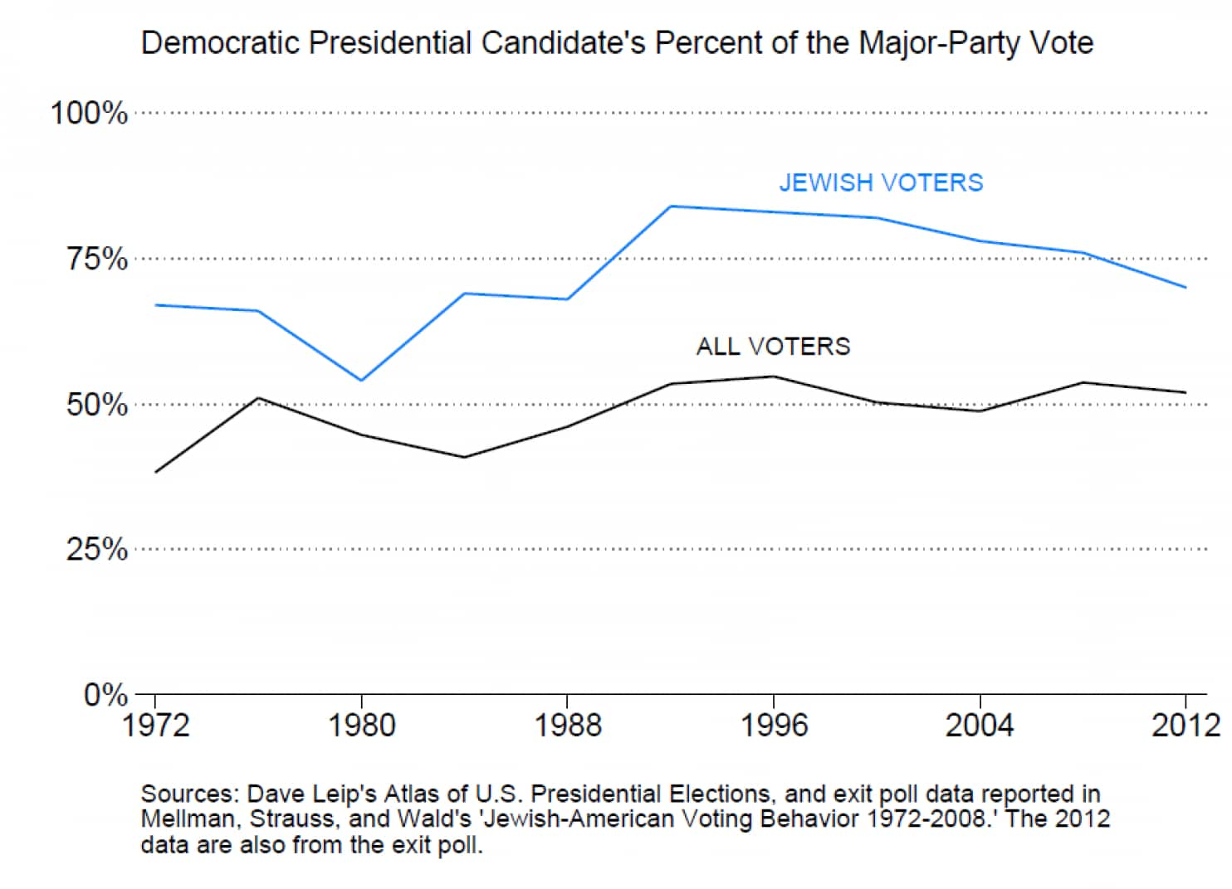
Q: Your argument discounts explanations that depend on the distinctive aspects of Judaism. For example, you say that it’s not that Jewish values promote liberalism, or that liberals have historically been more accepting of Jews, or that Jews tend to make common cause with other socially marginalized groups on the left, like blacks. What’s wrong with those explanations?
I criticize what I call “Judaic” theories that emphasize Jewish values, Jewish historical experience, and minority consciousness as the cause of this liberal/Democratic skew among American Jews. I don’t mean to deny that one can interpret Judaism as intrinsically left-liberal or read the historical record to conclude that liberals have historically been supportive of Jewish aspirations, or that having been a stigmatized minority may engender Jewish empathy with other oppressed groups.
But these explanations don’t help us explain political differences among Jews across countries or over time. American Jews share a religious tradition, historical inheritance, and minority status with most Jewish communities around the globe — and yet only Jews in the United States are concentrated on the left. Jews outside the U.S. are sometimes centrist, sometimes rightist, and occasionally indistinct from the general population, but never as tightly clustered on the left as American Jews.
And if, as these theories presuppose, liberalism is intrinsic in the Jewish experience, how can we explain short-term fluctuations in American Jewish political behavior? Judaic theories are universal and static, so they cannot account for American Jewish political exceptionalism nor the oscillations in American Jewish voting patterns.
Q: Your explanation centers on something different: the desire of Jews to defend the separation of religious identity and membership in the state. Where does this desire come from?
My account of American Jewish political behavior emphasizes the uniqueness of the American context. The U.S. Constitution follows a classic liberal model in separating citizenship and religion. Rather than rooting citizenship in blood or religion, the American system eliminates ethnic particularity as a condition for full membership in the political community.
This arrangement resonates powerfully with American Jews for practical reasons — it gives them a chance to participate as equals in a way they had not experienced elsewhere — and it differs radically from their historical experience as, at best, a “tolerated” minority whose status often changed on the whims of rulers.
American Jewish communities in the late 18th centuries celebrated the Constitution’s prohibition on religious tests in Article VI as their Magna Carta. Despite the passage of centuries, they have remained deeply attached to the idea of a secular state, believing that it accounts for their integration in what some have described as the “Kingdom of Kindness.”
Q: How does this account help us explain why Jews tend to vote for Democrats, and why that tendency is sometimes stronger or weaker?
Most Jews embrace the classic liberal regime of religion and state in the U.S. and typically support candidates that they perceive as most committed to it. Since the New Deal at least, the Democrats have been that party, but the pattern has occasionally been disrupted. For example, under the influence of identity politics in the late 1960s, Democrats favored policies that seemed to some American Jews to violate the classic liberal idea by granting legal privileges and benefits on the basis of race and gender. In reaction, the Democratic vote share among Jews dropped significantly and oscillated in the 1970s and 1980s.
When, however, the Republican party reached out to white Protestant evangelicals, who eventually came to constitute the party’s base, Jews reacted negatively because they perceived a threat to the liberal regime. Evangelicals, with their “God talk,” insistence on a “Christian America,” and general willingness to deny fundamental liberties to some minorities on religious grounds, struck many American Jews as a fundamental danger to core values of the polity. Accordingly, Jewish support for Democratic presidential nominees rose from roughly two-thirds to three-fourths in the 1990s and thereafter.
Even the glaring exception, the Republican-oriented Orthodox Jewish community, manifests similar dynamics. Less concerned with integrating in the manner of most American Jews, some of the Orthodox support Republican candidates who promise policies like tuition tax credits that might facilitate communal integrity. The point is that Jews strategically adapt their political behavior in response to the agendas and rhetoric of the political parties.
Anything you want to add for Steve King’s benefit?
Representative King seems to assume that most American Jews are diehard Likudniks, when the evidence runs decidedly in the opposite direction. In fact, much of the estrangement of American Jews from the current Israeli government is rooted in concerns over the growing ethnic and religious nationalism of the right-wing bloc so evident in the Likud’s recent campaign against Israel’s Arab citizens.
For all their commitment to Israel, many American Jews (and Israelis) have long objected to the role of the Israeli state in “establishing” Orthodox Judaism by providing it with generous public funding and quasi-legal authority in matters of personal status. Many activists in the American Jewish diaspora have called on Israel to embrace the classic liberal model, promoting and funding efforts that advance such values as tolerance, democracy and religious pluralism. That really underscores the tenacity of classic liberalism in the political calculus of most American Jews.

